Project Title: Propel Pals

Team #: 5

Team Members: Darrin Yuhn, Yuxi Mao, Stephanie Retzke, Akhila Atluri

GitHub: https://github.com/stefanista/HolyHandGrenades

**Project Goal and Objectives:**

* **Motivation**

Primary motivation in undertaking this project is to produce an application that will benefit fellow UMKC students participating in the Propel Program. We wish to participate in fostering further positive relations between a student and their mentor by allowing the student a means to communicate through the application and the ability to provide feedback on their progress. Our aim is to provide a means of enhancing their student experience here at UMKC.

* **Significance**

The Propel Program would like to receive feedback on each Propel student’s progress and allow a means of communication for the student. The ability to observe how a student is doing throughout the program and to hear from them about their experience day to day will allow for adjusting the program to meet new needs that may or may not be currently apparent. The program would like for the application to provide a means for a Propel student to monitor their progress, have a channel of communication that may reduce a shy student’s hesitation to share their experience, and to communicate with their mentor.

* **Objectives**

Objectives we would like to complete include creating a working chat feature that will allow communication between the Propel student and their mentor. The chat will be like an instant message system that conveys text between the two users. We also would like to expand this to encompass multiple users.

Part of the requirements for the application is to present a Propel Student with survey like questions every day to check in on the student’s well being as well as have overall feedback regarding the program. The objective we would like to achieve is to allow an anonymity feature to express feedback to the Propel Program, alleviating some shy students’ hesitation to provide feedback.

We would like to have a UI presented to the student’s phone to access the different features, with the objective being creating a UI similar to the application Pacifica.

Allow the users to build a profile to display a little information about themselves and provide the option to have the students display their accumulated points.

We need to create a working database to hold the information.

Create a calendar application that allows the student to present their tasks for organization.

Allow augmented reality of the student’s tasks and survey questions.

Inquire with the Propel Program about incorporating a news section into the application to display UMKC related tweets to display to the students.

* **System Features**

We will feature augmented reality to present a student’s progress of their tasks.

One-on-one chat ability with mentor and the student

Chatroom like functionality to have students communicate with one another

Push surveys to students’ phones to answer questions.

Anonymous functionality to have students communicate concerns they do not want associated with them.

A scheduler for students to monitor their tasks.

Ability to retrieve notifications of events at UMKC.

Anonymously reply to program evaluations.

* **Prioritized Features and Technologies**

Priority features for this project include the survey functionality and the chat functionality. The document about the project from the Propel Program prioritizes the ability to communicate with the students and the ability to check in on their status. This is accomplished by means of sending program evaluation questions through notifications and through inquiring about their status periodically through the course of the program.

The student should be able to message their mentor quickly. By having an easily accessible element to the student, he or she can message their mentor without having to go through too much of the interface.

Technologies used for this project will be Ionic, MySQL, Backand, Twitter API, CloudSight, and ARToolKit.

**Related Work:**

* <http://www.thinkpacifica.com/>
* <https://www.whatsapp.com/>
* <https://camfindapp.com/>

**Bibliography:**

* <https://blog.ionicframework.com/built-with-ionic-pacifica/>
* <https://multi-os-engine.org/>
* <https://www.artoolkit.org/>
* <https://cloudsight.ai/api>
* <https://ionicframework.com/docs/v1/guide/preface.html>
* <https://blog.ionicframework.com/creating-an-ionic-app-with-mysql-and-backand/>

Schedule for Increment 1: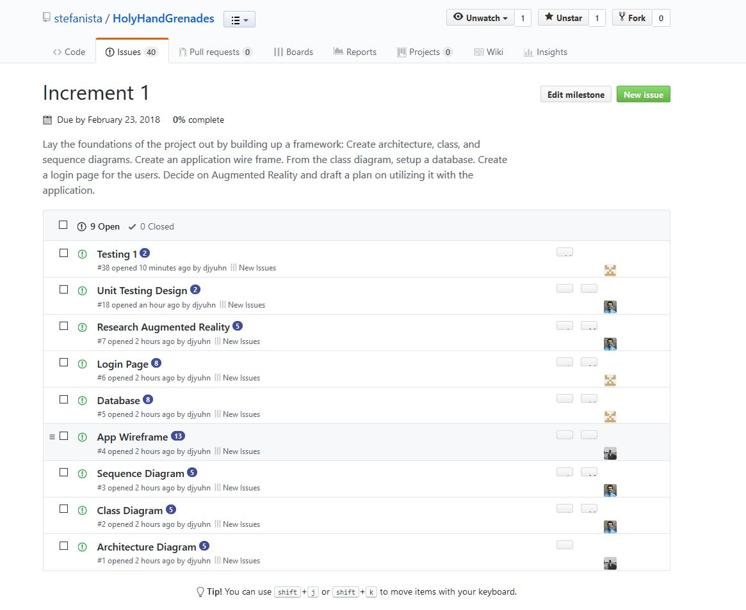

Schedule for Increment 2: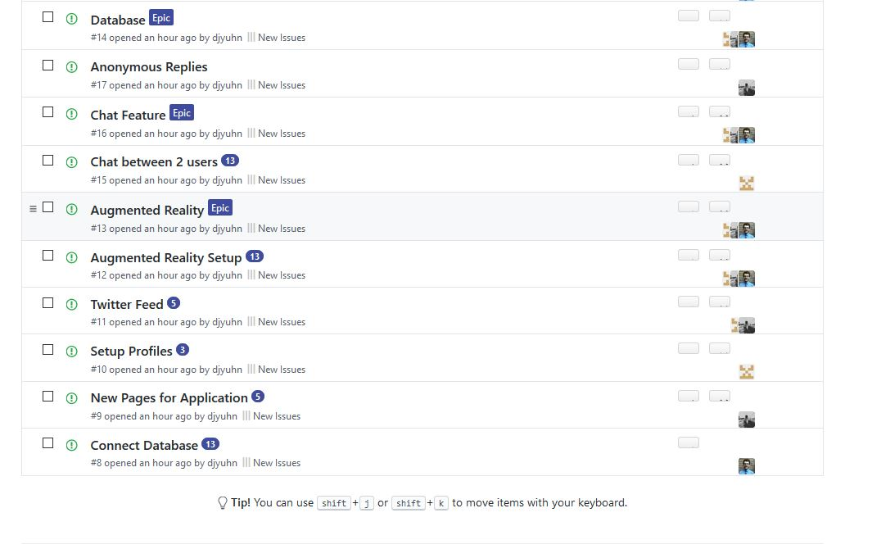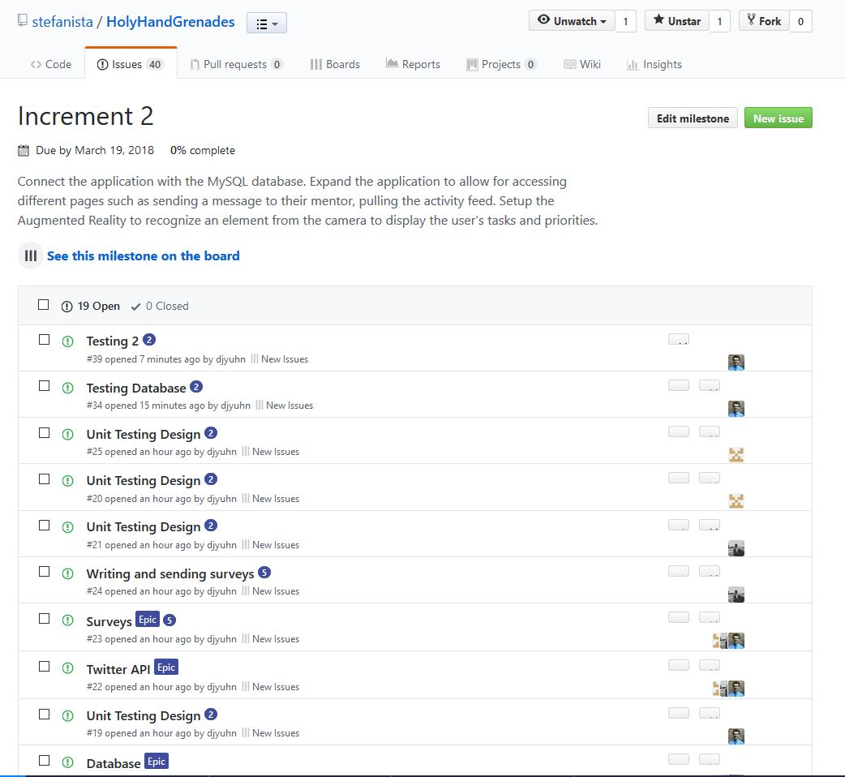

Schedule for Increment 3: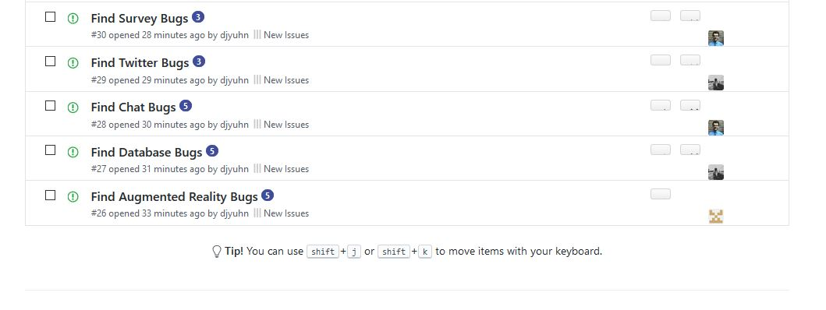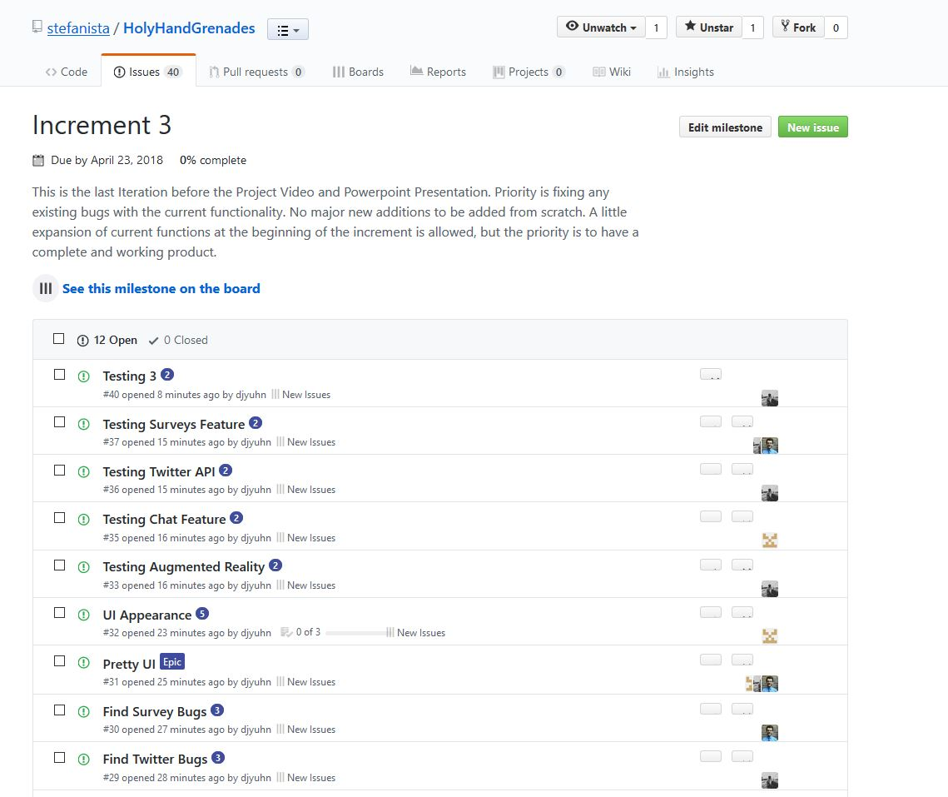

Burndown for Increment 1: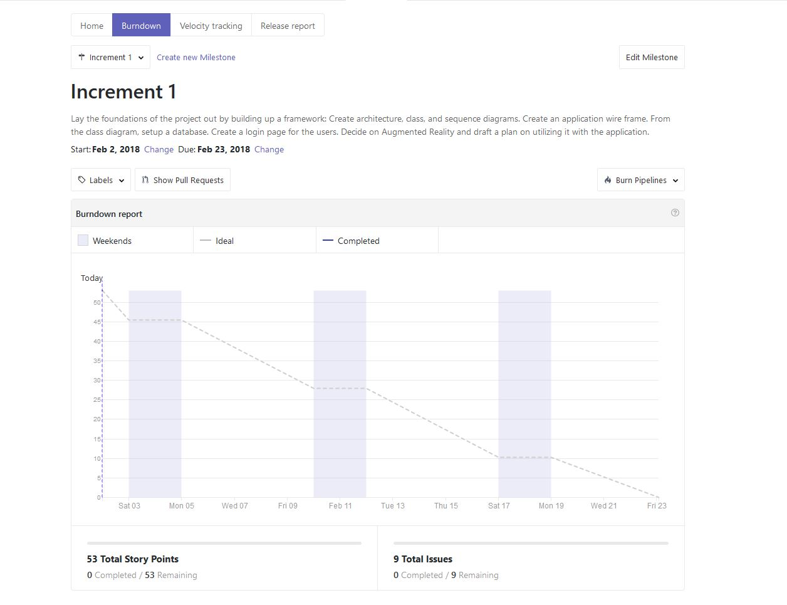

Burndown for Increment 2:

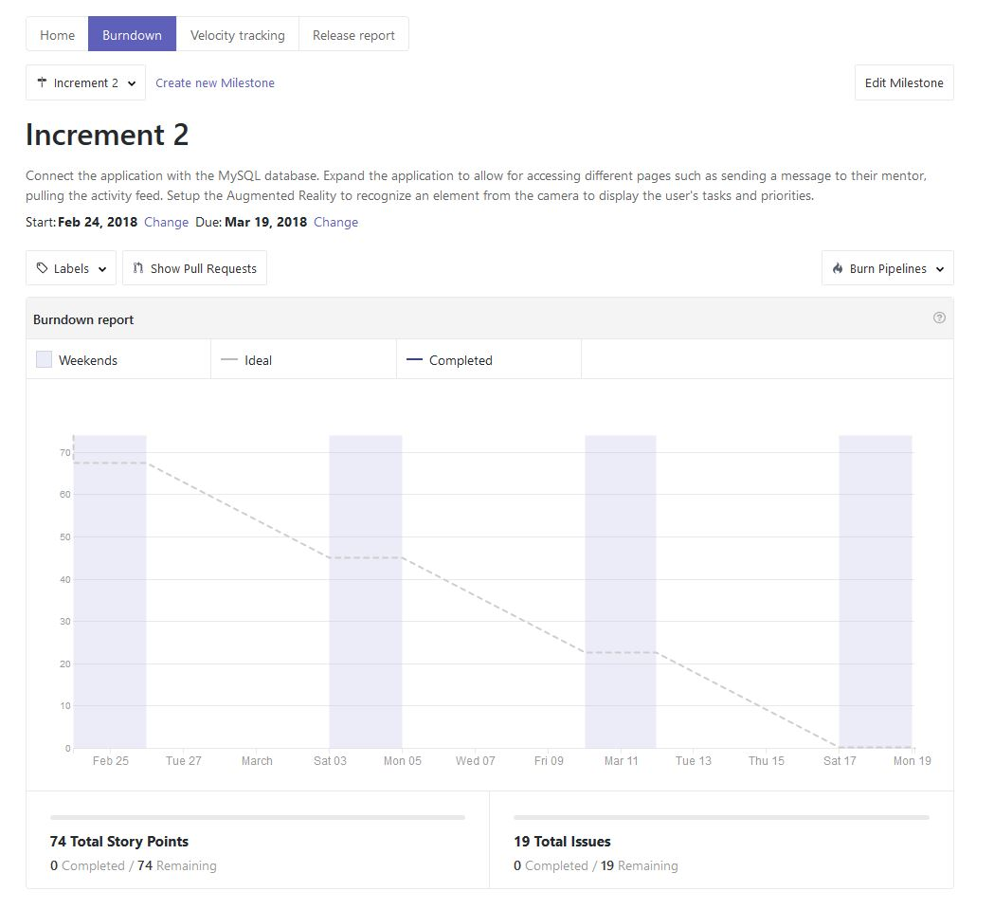

Burndown for Increment 3:

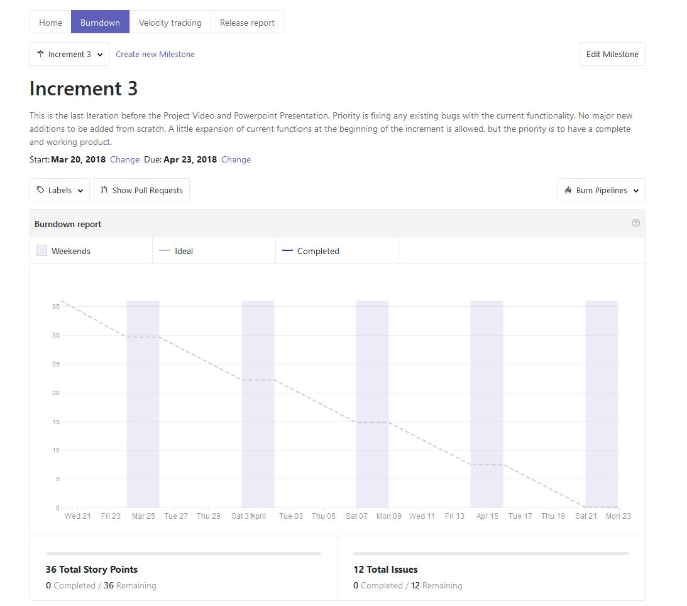

Task Responsibility for Darrin Yuhn: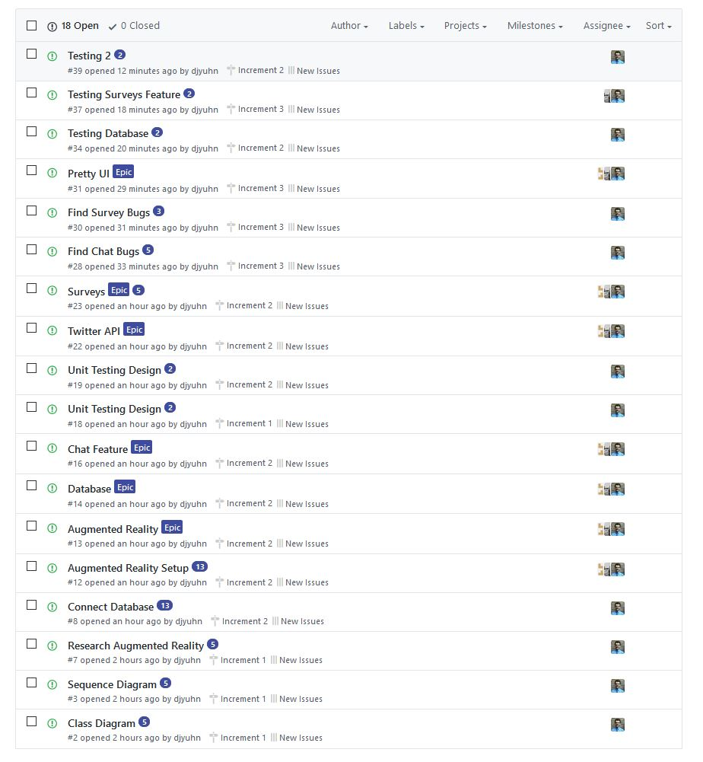

Task Responsibility for Stephanie Retzke:

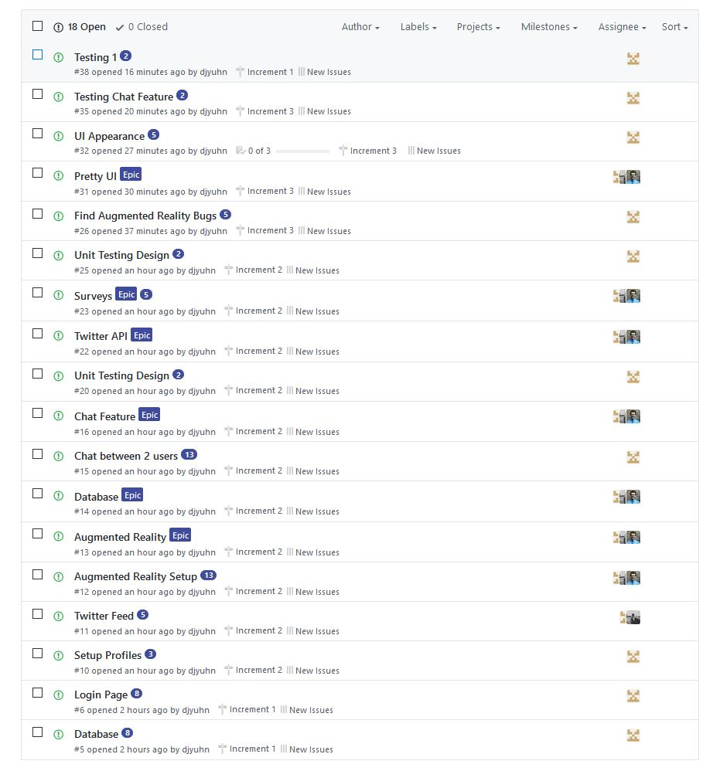

Task Responsibility for Yuxi Mao:

